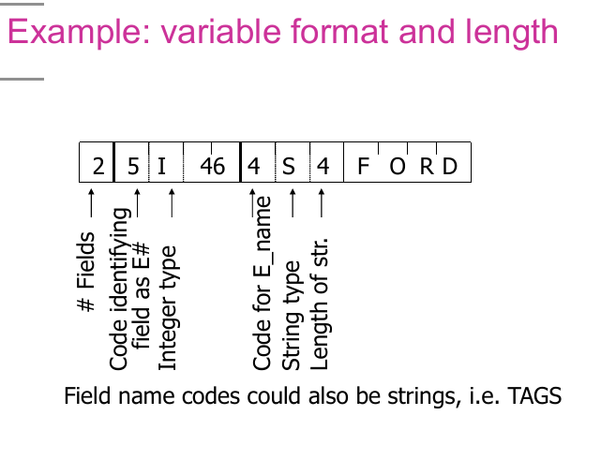

This diagram is showing an example of a variable format and length record in DBMS storage.
Let’s break it down step-by-step:

1. Understanding the Components
[ 2 ][ 5 ][ I ][ 46 ][ 4 ][ S ][ 4 ][ F ][ O ][ R ][ D ]
- 2 → # Fields in the record (here, 2 fields).
- 5 → Code identifying the first field (meaning “field E#” — Employee Number).
- I → Data type of the field (Integer).
- 46 → The actual integer value of field E# (Employee number 46).
- 4 → Code identifying the second field (meaning “field E_name”).
- S → Data type of the field (String).
- 4 → Length of the string (4 characters).
- FORD → Actual string data (Employee name "FORD").

2. Key Concepts
- Variable format: Each field includes its own metadata (field code, type, length if applicable).
- Variable length: String fields store their own length, allowing different sizes.
- Self-describing records: The record contains enough info to interpret it without needing a separate schema definition.

3. Why This Matters
- Useful in semi-structured data (e.g., XML, JSON in DBMS).
- Allows schema evolution — you can add/remove fields without breaking existing records.
- Slightly more storage overhead due to repeated metadata for each field.

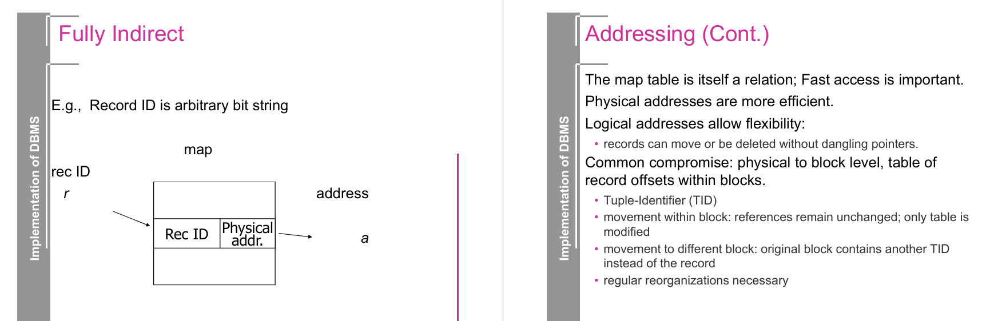
Addressing in DBMS storage systems — specifically how DBMSs keep track of where tuples (records) are stored on disk. Let’s break it down step by step.

🔹 The Problem
- Records are stored in blocks on disk.
- We need a way to refer to each record efficiently → so queries, indexes, and joins can quickly find it.
- Records can be moved, deleted, or updated, which complicates addressing.

🔹 Physical vs. Logical Addresses
- Physical addresses
  - Directly point to the byte offset on disk (e.g., "Block 1234, byte 512").
  - Very fast, but fragile: if a record moves, all references to it break (dangling pointers).
- Logical addresses
  - Use an indirect reference (e.g., "record ID = 777") and keep a map table that translates logical → physical location.
  - More flexible: record can move without breaking references, since only the table is updated.
  - Slightly slower (extra lookup).

🔹 Common Compromise in DBMS
DBMSs usually mix both approaches:
- Physical addressing to the block level.
  - Each record is identified by its block number (fast access).
- Logical addressing inside the block.
  - Within a block, a slot table (offset table) tells where each record starts.
This approach balances efficiency and flexibility.

🔹 Tuple Identifier (TID)
- Each record is given a TID = (BlockID, SlotID).
- Example: TID = (123, 5) means "record in Block 123, slot 5".

Behavior
- Movement within the same block:
  - If a record is shifted (e.g., after deletes/compaction), only the slot table inside the block changes.
  - The TID remains valid.
- Movement to a different block:
  - Instead of changing all references, the original block stores a forwarding address (new TID).
  - Queries follow the forwarding pointer to the new location.
- Regular reorganizations are needed:
  - Too many forwarding pointers hurt performance.
  - DBMS periodically compacts/reorganizes blocks to restore efficiency.

🔹 Why this matters
- Fast lookups: queries and indexes depend on stable record identifiers.
- Updates & deletes: records must be relocatable without breaking references.
- Reorganization: keeps storage clean and performance high.

✅ Summary in one line:
DBMSs use TIDs (BlockID, SlotID) for addressing, combining physical block-level addressing (fast) with logical slot tables (flexible), and handle record movement by updating slot tables or forwarding TIDs, plus periodic reorganizations to maintain efficiency.

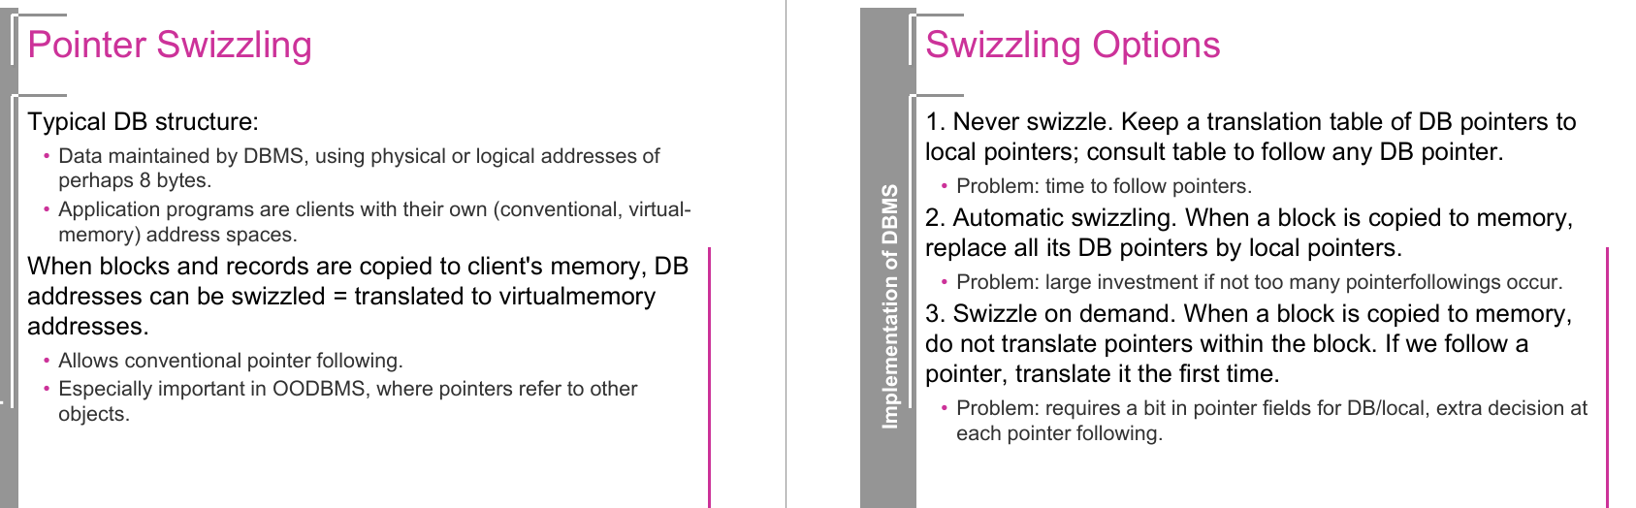

🔑 Pointer Swizzling
- DBMS stores addresses → either physical or logical (e.g., 8 bytes).
- Client applications → have their own virtual address space.
- When blocks/records are copied into client memory, DB addresses can be "swizzled" (translated) into virtual memory addresses.
- Benefit: enables normal pointer following like in programming languages.
- Key use: in Object-Oriented DBMS, where records/objects contain references (pointers) to other objects.

🔄 Swizzling Options
- Never swizzle
  - Keep a translation table: DB pointer → local pointer.
  - Each pointer access = lookup in the table.
  - Problem: slow (extra time every time you follow a pointer).
- Automatic swizzling
  - When a block is copied → convert all DB pointers in it to local pointers immediately.
  - Problem: wasteful if few pointers are actually used (big upfront cost).
- Swizzle on demand
  - When a block is copied → keep DB pointers as-is.
  - Only when a pointer is actually used for the first time, swizzle it.
  - Problem: needs an extra bit/flag in pointer fields and an extra check each time.

✅ Summary table for clarity:
Option | How it works | Pros | Cons
Never swizzle | Keep translation table, no conversion | Simple, low upfront cost | Slow lookups for every pointer
Automatic swizzle | Convert all DB → local when block loaded | Fast pointer following later | High cost if few pointers are followed
On-demand swizzle | Convert only when a pointer is first used | Balanced, avoids waste | Needs flag + decision per pointer use

🎯 Example: Object Database with Swizzling
Suppose we have three objects stored in the database:
- Object A → has a pointer to Object B
- Object B → has a pointer to Object C
- Object C → contains just data (no further pointer).

Case 1: Never Swizzle
- DBMS loads Object A into memory.
- A’s pointer to B is still a DB address (not a local pointer).
- To follow A → B:
  - Look into the translation table: DB address of B → memory address of B.
- Every access goes through the table.
- ✅ No upfront cost.
- ❌ Slow if we follow pointers a lot.

Case 2: Automatic Swizzle
- DBMS loads Object A.
- It immediately replaces A’s DB pointer to B with a local memory pointer.
- Then, when B is loaded, its pointer to C is also swizzled automatically.
- Now A → B → C follows normal pointers (fast like in C/Java).
- ✅ Super fast pointer chasing.
- ❌ If B or C are never accessed, wasted time doing swizzling.

Case 3: On-Demand Swizzle
- DBMS loads Object A.
- A’s pointer to B is still a DB pointer (with a flag bit saying “not yet swizzled”).
- First time we follow A → B: DBMS translates it into a local pointer, updates A’s field.
- If later we follow A → B again, it’s already a local pointer → fast access.
- ✅ Balanced: no waste if we don’t use pointers.
- ❌ Slight overhead: extra check each time we dereference.

🔑 Analogy
Think of it like Google Maps navigation:
- Never swizzle → every time you drive, you ask Google Maps again (slow but no prep).
- Automatic swizzle → you download the entire map offline (fast but heavy upfront).
- On-demand swizzle → you only download a route when you first drive there, then reuse it later.

Here is a detailed explanation of the “Representing Data Elements” lecture (WS 24/25, Prof. Dr. Justus Klingemann), along with recommended online resources and top-rated YouTube content for each topic.

🔍 Summary of Key Concepts in the Lecture

1. Data Representation in DBMS
Term | Meaning
Field | A sequence of bytes representing a value (e.g. "salary")
Record | Sequence of fields = a tuple
File | Collection of blocks holding records

Relational vs Object-Oriented View
- In OOP: Field → attribute; Record → object; File → class extent

2. The Mapping Problem
You store human-understandable data (e.g. names, dates, pictures) using only bytes and bits.
Data Type | Encoding
Integers | 2 or 4 bytes
Floating Point | Mantissa + Exponent
Characters | ASCII (e.g., ‘A’ → 1000001)
Booleans | e.g., TRUE = 11111111, FALSE = 00000000
Enumerations | Encoded using small integers (RED=1, GREEN=3, etc.)
Strings | Null-terminated, Length-prefixed, or Fixed-length

3. Dates and Times
- Dates: YYYYMMDD, YYYY-DDD, or #days since 1900
- Time: HHMMSS format or seconds since midnight

4. Record Layouts
- Fixed-length: Every field has a set size (better for alignment)
- Variable-length: Fields or repeating fields vary in length
- Record Headers: Store meta info (e.g. schema, length, timestamp)

5. Variable Formats
- Fields identified by tags or names, making data self-describing (useful for integration)

6. Blocks and Record Storage
- Block = basic unit on disk, with:
  - Header (metadata, pointers)
  - Records

Techniques
- Spanned: Record can span across multiple blocks
- Unspanned: Record must fit inside one block
Benefit | Trade-off
Spanned: Better utilization | Harder to manage
Unspanned: Simpler | Wastes space for large records

7. Clustering & Mixed Records
- Clustering stores related records (e.g. CUSTOMER, DEPOSIT) in the same block.
- Useful for frequent joins, but bad for full table scans.

8. Sequencing
- Records ordered by a key for faster merge-joins.
- Options:
  - Physically contiguous
  - Linked list
  - Overflow area

9. Addressing Records
- Physical: Device ID, cylinder, block number
- Logical: Indirect mapping using abstract Record IDs (TID = Tuple Identifier)

10. Record Movement & Deletion
- Deleting records creates dangling pointers or holes.
- Use tombstones to avoid breaking pointers.

11. Pointer Swizzling
- Translating DB pointers into application memory pointers.
- Options:
  - Never swizzle (slow)
  - Swizzle all at once (costly)
  - Swizzle on demand (best trade-off)

Alright — this lecture is about Representing Data in DBMS (physical storage structures).
I’ll walk you through the topics in a logical order, then give you a concise summary at the end.

1. Physical Layout of Data
In relational terms:
- Field → bytes representing an attribute value in a tuple.
- Record → tuple = sequence of fields.
- File → collection of blocks holding tuples.
In object-oriented terms:
- Field = attribute/relationship
- Record = object
- File = extent of a class

2. Mapping Problem
We want to store things like salaries, dates, pictures, but we only have bytes.
DBMS must map high-level data types → low-level binary representation.

3. Representation of Data Types
- Numbers
  - Integers (2 or 4 bytes, binary encoding)
  - Floating point (split into mantissa & exponent)
- Characters
  - ASCII encoding (7-bit codes), Unicode for multi-language.
- Boolean
  - Often stored as 1 byte (TRUE/FALSE)
  - Application-specific enumerations possible.
- Dates & Times
  - Multiple formats (integer days since epoch, character formats like YYYY-MM-DD).
- Strings
  - Null-terminated, length-prefixed, or fixed-length.

4. Records
- Fixed-length records
  - Easy to manage, but may waste space.
  - Fields may need alignment to 4/8 bytes for efficiency.
- Record headers
  - Metadata: pointer to schema, length, timestamp, etc.
- Variable-length records
  - Occur when fields vary in size, repeat, or are self-describing.

5. Internal Organization of Records
Two main strategies:
- Each field preceded by a length.
- Record header contains pointers (offsets) to variable fields.
Hybrid format:
- Part fixed, part variable.
- Or store fixed part in one place and variable part separately.

6. Placing Records into Blocks
- Block header: links, role info, record directory, timestamp.
- Options:
  - Separating records (marker, lengths, or fixed-size assumption)
  - Spanned (record split across blocks) vs unspanned (fits entirely in one block)
  - Mixed record types (clustering related data)
  - Split records (fixed in one block, variable in another)
  - Sequencing (order by key for fast range scans)
  - Addressing (physical vs logical)

7. Addressing Records
- Physical: exact disk location.
- Logical: abstract ID → map table → physical location.
- TID (Tuple Identifier): combines block ID & record offset.
- Allows relocation within block without changing TID.

Addressing in DBMS
When the DBMS needs to find or refer to a record, there are two main approaches:

1. Physical Addressing
- Definition: Directly store the exact physical location of the record on disk.
- Contents: Typically a sequence of numbers that describe exactly where the record is.
- Example for HDD:
- [Device ID][Cylinder #][Surface #][Block # within track][Offset within block]
  - Device ID – Which disk drive.
  - Cylinder # – Which cylinder (aligned tracks across platters).
  - Surface # – Which platter surface.
  - Block # – Which block/sector within that track.
  - Offset – Position of record within the block.
Pros:
- Fast lookup — no indirection.
- Works well in static storage (no movement of records).
Cons:
- Breaks if record moves (e.g., after defragmentation or reorganization).
- Not portable across devices.

2. Logical Addressing (Indirect)
- Definition: Use an abstract identifier (logical ID) to refer to a record, and store a mapping table that tells the DBMS where it is physically.
- Example:
  - Record ID: CUST1023 → Mapping table → Physical location: (Disk 1, Cylinder 44, Surface 0, Block 8, Offset 32).
Pros:
- Records can be moved freely without changing the logical IDs.
- Easier maintenance and reorganization.
- Good for distributed databases.
Cons:
- Slightly slower — requires an extra lookup step in the mapping table.
- Mapping table must be kept consistent and up-to-date.

Typical DBMS Choice
Most modern DBMSs use logical addressing with something like a TID (Tuple ID):
TID = (Page ID, Slot #)
- Page ID → The page (or block) containing the record.
- Slot # → The position of the record within that page.
- If the record moves to another slot, the page’s slot directory is updated, and TID remains the same.

8. Deletion Handling
- Immediate reclaim (compact space)
- Mark deleted (tombstones)
- Reuse via free-space chains.

9. Pointer Swizzling
- Conversion of DBMS-level addresses to in-memory pointers.
- Options:
  - Never swizzle (use translation table)
  - Always swizzle (on block load)
  - Swizzle on demand
- Must unswizzle before writing block back to disk.

📌 Summary Table
Topic | Key Points
Physical layout | Field → Record → File → Block
Data type mapping | Encode numbers, chars, bool, date/time, strings
Record types | Fixed vs variable vs hybrid
Internal organization | Length prefixes or offset tables
Block storage | Headers, separation, spanned/unspanned, clustering
Addressing | Physical vs logical, TIDs
Deletion | Immediate, tombstones, reuse
Pointer swizzling | Convert DB pointers to memory pointers

🧪 Practice Questions & Solutions

Q1.
In a DBMS, what is the difference between fixed-length and variable-length records? Give one advantage and one disadvantage of each.
Solution:
- Fixed-length: All records occupy the same amount of space.
  - Advantage: Easy to compute record positions; fast access.
  - Disadvantage: Wastes space if fields are not fully used.
- Variable-length: Size of record can differ depending on data.
  - Advantage: Saves space for shorter values.
  - Disadvantage: More complex to manage; requires offsets or length fields.

Q2.
Why is alignment used in storing fixed-length records?
Solution:
Alignment ensures that fields start at memory addresses that match the CPU’s natural word boundaries (e.g., multiples of 4 or 8 bytes). This improves memory access speed and avoids CPU penalties for misaligned reads/writes.

Q3.
What is the difference between physical addressing and logical addressing in record storage?
Solution:
- Physical addressing: Directly stores the location of a record on disk (e.g., block number + offset).
- Logical addressing: Uses an abstract record ID (TID) that maps to a physical location through an indirection table. This allows records to be moved without changing their ID.

Q4.
A DBMS stores records with the following structure: 4-byte integer ID, 20-byte fixed name, variable-length description. How could you store this record efficiently?
Solution:
- Store ID + name in fixed-length part of record.
- Store description in variable-length section with offset recorded in header.
- This hybrid format keeps frequent accesses fast while allowing flexibility for variable data.

Q5.
What is a TID and why is it useful?
Solution:
- TID (Tuple Identifier): A unique identifier for a tuple, usually composed of a block ID and slot/offset number.
- Useful for:
  - Quick direct access to records.
  - Moving records within a block without changing the identifier.
  - Maintaining references during updates.

Q6.
Explain the difference between spanned and unspanned record storage.
Solution:
- Spanned: A single record can be split across multiple blocks.
  - Pros: Can store large records.
  - Cons: Slower access, requires multiple reads.
- Unspanned: Each record fits entirely in one block.
  - Pros: Faster access.
  - Cons: May waste space for partially filled blocks.

Q7.
What is pointer swizzling and why do we need to unswizzle?
Solution:
- Pointer swizzling: Replacing a logical DBMS address with a direct in-memory pointer when a page is loaded into memory.
- Unswizzling: Converting it back to a DBMS address before writing the page to disk (so the disk doesn’t store invalid memory addresses).

Q8.
When deleting a record, why might a DBMS choose to leave a tombstone rather than immediately reclaiming space?
Solution:
- Leaving a tombstone preserves references (e.g., foreign keys, indexes) that still point to the deleted record’s location.
- Immediate space reclamation might break those references unless all are updated.

DBMS Data Representation – Cheat Sheet

1. Storage Hierarchy
- Field → Record → File → Block
- Field = attribute value
- Record (tuple) = collection of fields
- File = collection of records
- Block = fixed-size unit read/written from disk

2. Mapping Problem
- Convert high-level data types → low-level byte sequences.
- DBMS must handle numbers, text, dates, images, etc.

3. Data Type Representation
Data Type | Storage
Integer | 2 / 4 bytes (binary)
Float | Mantissa + exponent
Boolean | 1 byte (TRUE/FALSE)
Char | ASCII / Unicode
Date/Time | Epoch-based int or formatted string
String | Null-terminated, length-prefixed, fixed-length

4. Record Types
- Fixed-length: Constant size, simple addressing, but wastes space.
- Variable-length: Saves space, but needs length fields or offsets.
- Hybrid: Fixed part + variable part.

5. Internal Record Organization
- Length prefix: Each field preceded by length.
- Offset table: Header contains pointers to variable fields.
- Null bitmap: Marks which fields are NULL.

6. Block Layout
- Header: Metadata (links, role, free space)
- Record area: Actual tuples
- Record directory: Offsets to records
Spanned = record split across blocks
Unspanned = record fits within one block

7. Addressing Records
- Physical address: Direct disk location.
- Logical address: TID = (Block ID, Slot #) → allows movement without breaking references.

8. Deletion Strategies
- Immediate reclamation: Remove and compact.
- Tombstones: Mark deleted but keep space reserved.
- Free-space chains: Link empty slots for reuse.

9. Pointer Swizzling
- Replace DB address with in-memory pointer on load.
- Always swizzle: Do it for all on load.
- On-demand swizzle: Only when accessed.
- Never swizzle: Use translation table.
- Must unswizzle before writing page to disk.

✅ Exam Tip:
Always think in layers — how the DBMS represents data in memory is different from how it’s stored on disk, and addressing methods bridge this gap.

